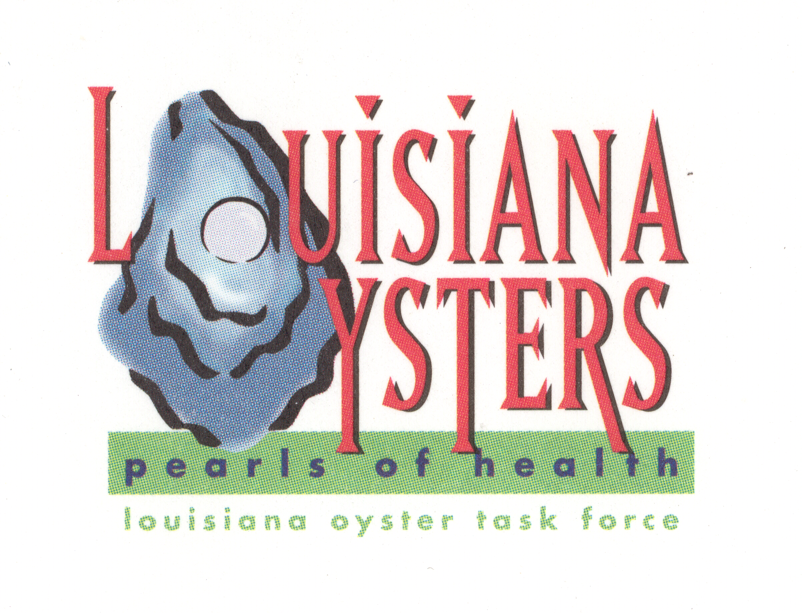

Louisiana Oyster Task Force Meeting
John Tesvich, Chairman

Tuesday Jan 25, 2011 1:00 PM
UNO Advanced Technology Center, 2021 Lakeshore Drive, Suite 210

Minutes

Meeting called to order at 1:05 p.m.
- Roll Call- Present: Shane Bagala, Patrick Banks, Dana Brocato, Glenn Cambre, Wilbert Collins, Dan Coulon, Bryon Encalade, Jakov Jurisic, Steve McManus in for Keith LaCaze, Karl Morgan, Ralph Pausina, Brad Robin, John Tesvich, Sam Slavich, Peter Vujnovich, Mike Voisin
Absent: David Deere, Jerome Zeringue
- Approval of Nov 30, 2010 MINUTES-motion by Wilbert Collins to approve, second by Mike Voisin
- Treasury Report
  - Oyster Tag Sales-December tag sales-34,900.
B. LOTF Financial Report –John presented Cash flow budget sheet. Mike Voisin moved to accept treasures report, second by Wilbert Collins. Motion carries
IV. Committee Reports
A. Public and Private Oyster Grounds Committee – (Buddy Pausina)
B. Enforcement - (Keith Lacaze)-Steve McManus reported for Keith Lacaze
C. Legislative - (Jakov Jurisic)-Jakov did not have anything to report due to personal issues. Mike Voisin presented a draft letter to Mary Landrieu based on the 2004 letter from FDA and EPA to aimed at women who are or might be pregnant. Motion to send letter by Wilbert Collins, second by Byron Encalade. Byron also asked that we recognize her specifically for her contributions to the SBA program providing emergency loans to fishermen. Motion carries. Mike Voisin spoke on the effort underway in Washington to reintroduce tax bill. Wicker was going to be introducing that bill.
D. Research – (John Supan)-John didn’t have a committee report, but reminded people that the Oyster convention is taking place in a couple of weeks.
E. Coastal Restoration – (Dan Coulon)-
F. Marketing - (Dana Brocato)-Dana presented survey. John discussed the grant options via seafood board grant writer. Motion by Wilbert Collins to move forward with value added grants with aid of grant writer from seafood promotion and marketing board and move to marketing committee. Second by Mike Voisin.

G. Health – (Glenn Cambre)-Tuesday, Feb 1 from 2 p.m.-4 p.m. 628 North Forth Street. Rm 188 in Bienville Building (DHH headquarters), large conference room downstairs. Topic is sale of oysters for raw consumption. Jakov requested that this meeting be held in other areas besides just Baton Rouge…maybe Belle Chasse or New Orleans. Motion made by Jakov to contact DHH and request this, second by Peter Vujnovich. Request 4 meeting locations. Glenn will provide John with a contact number for the appropriate folks at DHH to make this request. Motion carries.
V. Old Business
    - Public Oyster Reef Evaluation – Patrick Banks- no change in what was reported in late November. Area 1 and 2 have basically no spat set. Al made a motion to recommend to commission and secretary that they open east side of the river in Coastal Study area 2 open for February and March for sacking only. Second by Mike Voisin. Motion rejected. Motion by Ralph Pausina to set up a day for someone to volunteer a vessel and take the department on the water to see what oyster resources are available. Second by Mike Voisin, second carries. Vessel volunteered by Shane Bagala. Motion carries.
    - BP Oil Spill Remediation
      - Claims Process-development of oyster models are still under development, attny general is making final review, but should be ready shortly. $15 million has been requested to BP for oyster cultch.
      - Public Reef Remediation-Mike made a motion that $10 million of the $15 million dollars go to remediation of public reefs (cultch planting) and the remainder ($5 million) go to private leases. He asked that a POLR program be put in place in CSA 2 . Second by Al Sunseri. Substitute motion by Dan Coulon to do a 60/40 split of $15 million coming down for oyster rehabilitation. 60 percent for public leases and 40 percent to private leases. Mike Voisin seconds the substitute motion as a friendly amendment. Sunseri accepts friendly amendment. Motion carries.
      - Oyster Lease Remediation-
    - ISSC 2011 Board / VMC Meeting Report- Meeting in Orlando, Mike Voisin who sits on VMC committee and Al Sunseri who is on the board reported. Mike Voisin said that they had not accomplished the 60 percent illness rate reduction. November has significant clustering of instances, so it was recommended that in November there be more restrictions. FDA will be coming down to do Vv and Vp discussions. Committee will meet again in October in Seattle.
    - Oyster Lease Moratorium Update – Jerome Zeringue
Dan requested a presentation on map that has been put together by private land companies. Dan Coulon that shows what is claimed by state lands and what is duel claimed. John Tesvich suggested it be put on the agenda for next meeting.
VI. New Business
- Washington Walk on the Hill – Byron will go in place in Dan Coulon to D.C.
Advisory committee update-the group has met 3 times and will meet again at the end of February. Feb 16 in Belle Chasse auditorium. Ashley will contact Chip Kline to make sure they know about the next meeting.
- Election of Officers- Ralph Pausina recommended that all officers stay in their current offices, second by Wilbert Collins.

- Set Next Meeting- March 29, next OTF meeting, Tuesday 1 p.m.
- Adjourn-Motion to adjourn by Al Sunseri second by Wilbert Collins.

